ANALYSIS OF THE INFLUENCE OF SEGMENTING, TARGETING, AND POSITIONING ON PURCHASING DECISIONS AT PONDOK SALERO RESTAURANT, KEDIRI
Muhammad Alwi1 and Ema Nurzainul2
PGRI Nusantara University, Kediri,
Jl. KH. Ahmad Dahlan, No. 76 Mojoroto, Kediri City, East Java, 64112, Indonesia
alwimuhammmad04@gmail.com¹Andemahakimah@unpkediri.ac.id²
*corresponding author

Article Information |  |  | Abstract
Submission date |  | Research aim :The purpose of this study was to determine the influence of segmenting, targeting, and positioning on purchasing decisions at the Pondok Salero Kediri restaurant.  Design/Method/Approach :The method used in this research is quantitative.Sampling technique using techniquenonprobability sampling. The sample taken in this study were consumers who bought Padang cuisine at Pondok Salero Restaurant, Kediri, totaling 40 people. The measurement used in this study was by using the SPSS version 25 analysis tool.  Research Findings :The results of the t-test study indicate that the segmenting, targeting, and positioning variables partially have a significant effect on purchasing decisions. Based on the results of the F test, it is known that the segmenting, targeting, and positioning variables simultaneously have a significant effect on purchasing decisions.  Theoretical contribution/Originality :segmenting, targeting, and positioning play a role as the basis for creating an effective and efficient marketing strategy. By dividing the market into relevant segments, selecting potential segments, and strategically positioning the menu, STP helps Pondok Salero Kediri restaurant significantly influence consumer purchasing decisions.  Practitionel/Policy implications:Implementing the right STP strategy, Pondok Salero Kediri restaurant can better understand market needs, target the right segment, and create an attractive image. Efforts such as providing relevant menus, attractive promotions, and satisfying dining experiences can increase customer purchasing decisions while creating long-term loyalty.  Research limitations:Because this study proves that there are still other variables that influence purchasing decisions, this can be used as material for conducting similar further research to obtain better results.  Keywords :segmenting, targeting, positioning and purchasing decisions
Revised date
Accepted date

1. Introduction
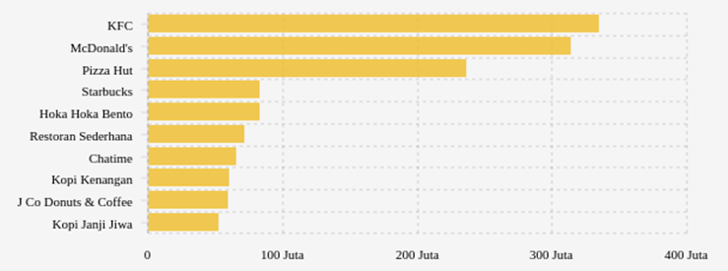
The restaurant industry is a growing industry in Indonesia. The food and beverage sector continues to grow at the fastest rate worldwide, as evidenced in Indonesia, which accounts for around 34% of the industry in Indonesia.[1]. The basic problems often faced by small business owners are low market share and lack of marketing. Good and correct strategy development activities will strengthen small business promotion and can achieve high competitiveness. The many types of restaurants will create competition and also diverse consumer interests, restaurant industry players are required to meet consumer characteristics in choosing restaurants.

Figure 1. Best-selling Restaurants or Eateries in Indonesia 2023

From figure 1, that simple restaurants are ranked sixth best-selling in Indonesia, beating four other restaurants or eateries. So it is proven that there are still Indonesian people who like Padang cuisine rather than other fast foods. The impact is also felt by Padang food restaurants, the increasing business competition in the culinary field, business owners must have a marketing strategy such as segmenting, targeting, and positioning that is good enough so that consumers decide to eat at the Padang restaurant.
Pondok Salero restaurant has its own strategy to attract consumers to buy Padang cuisine including segmentation, targeting and positioning, for demographic segmentation targeting all levels of society from young to old, women and men such as providing Padang cuisine that is quite popular with everyone, namely rendang and dendeng. However, it is not only gender and age that are considered, but also those who psychographically follow the development of the lifestyle of the surrounding community. With the era of digitalization, Pondok Salero restaurants prefer to promote goods online such as Gofood or Grabfood, for advertising more from digital media or social media than conventional media such as billboards, brochures, and others. In the targeting strategy, it does not distinguish between buyers who work or do not work because Pondok Salero restaurants target as many consumers as possible from the upper to lower classes.
The market segmentation process, namely selecting and determining market groups into certain segments as targets to be served, is an important thing that must be done by marketers to reach better opportunities. The concept of market segmentation is dividing the market into certain heterogeneous segments using one or more attributes, such as age level, income, geography, lifestyle to determine the number of potential customers.[2]. Business actors in determining targeting by means of the target market that is targeted is a decision that will be aimed at in offering products, the target is a number of consumers who have the needs and characteristics as desired by retailers or companies. Targeting or determining the target market is a marketing activity in selecting and evaluating the market that will be targeted or the goal of offering the products produced.[3]. Furthermore, the positioning strategy is a way for retailers or companies to build trust and confidence in the minds of consumers towards products sold on the market. According to[4]stated that positioning is how to position a company's product that will be stored in the minds of consumers, companies need to understand how the brand of the product is always positioned in the minds of consumers.
Segmentation has a very strong relationship with purchasing decisions. By dividing the market into more specific segments, companies can tailor their marketing strategies and product offerings to the needs of each group. This increases consumer relevance and interest, encouraging them to make faster and more confident purchasing decisions. Targeting plays an important role in influencing purchasing decisions by allowing companies to focus more on serving the most potential market segments. By adjusting the right product and marketing strategy to the chosen target, consumers feel that their needs are met, increasing their likelihood of making a purchase. Effective positioning shapes consumers' positive perceptions of a product or brand, making the product stand out from the competition. This perception influences consumers' beliefs and preferences, which ultimately drives them to make purchasing decisions. Segmenting, targeting, and positioning (STP) play an important role in influencing purchasing decisions. With segmenting, companies understand consumer needs; with targeting, companies focus on the most potential consumers; and with positioning, companies build a strong product image in the minds of consumers. The combination of the three makes consumers more confident and motivated to make purchasing decisions.
Previous research such as research by[5]states that segmentation, targeting, and positioning influence purchasing decisions, these results are similar to research conducted by[6]which states that segmentation, targeting, and positioning influence purchasing decisions. However, in research by[7]stated that positioning does not influence purchasing decisions, whereas research conducted by[8]stated that segmentation, targeting, and positioning influence purchasing decisions. Other differences in previous studies are the type of business or research object, and Padang restaurants that have their own characteristics compared to other restaurants such as green chili sauce and red chili sauce, have distinctive spices, the appearance of dishes arranged like a pyramid, and so on.
Based on the phenomena and gap research that have been presented by the researcher, namely about segmenting, targeting, and positioning strategies for purchasing decisions, especially in the Padang food industry, the author is interested in conducting research entitled "Analysis of the Influence of Segmenting, Targeting, and Positioning on Purchasing Decisions at the Pondok Salero Restaurant, Kediri"

  - Statement of Problem
Based on this background, a research question is formulated as follows:
- Does segmentation strategy influence purchasing decisions at Pondok Salero Restaurant, Kediri?
- Does targeting strategy influence purchasing decisions at Pondok Salero Restaurant, Kediri?
- Does positioning strategy influence purchasing decisions at Pondok Salero Restaurant, Kediri?
- Do segmenting, targeting, and positioning strategies influence purchasing decisions at Pondok Salero Restaurant, Kediri?

  - Research Objectives
Based on the formulation of the problem, the objectives of this research are to:
- To determine and analyze the influence of segmenting strategies on purchasing decisions at the Pondok Salero Restaurant, Kediri.
- To determine and analyze the influence of targeting strategies on purchasing decisions at Pondok Salero Restaurant, Kediri.
- To determine and analyze the influence of positioning strategy on purchasing decisions at Pondok Salero Restaurant, Kediri.
- To determine and analyze the influence of segmenting, targeting, and positioning strategies on purchasing decisions at Pondok Salero Restaurant, Kediri.

2. Method
The research technique uses casual techniques, causal relationship techniques, so that it can be known which variables influence which variables are influenced. The population to be selected in this study is consumers who buy Padang cuisine at Pondok Salero Restaurant, Kediri. The sampling technique used in this study uses the accidental sampling technique.[9]the analysis used is multivariate with correlation or multiple regression, then, the number of sample members is taken 10 times the number of variables studied, then the sample taken in this study is consumers who buy Padang cuisine at Pondok Salero Kediri Restaurant, totaling 40 people. In this study, researchers used a structured questionnaire using the Likert Scale. The Likert Scale is used to measure attitudes, opinions and perceptions of a person or group of people about social phenomena. The measurement of validity and reliability that will be used in this study is by using the SPSS version 25 analysis tool.
Validity Test
Validity calculations are assisted by using the SPSS version 25 program. Based on the results of the calculation of the product moment person correlation coefficient with SPSS, the results are listed in table 1 below:

Table 1. Validity Test of Research Instruments
Variables | Item | rhitung | rtable | Information
Purchase Decision (Y) | 1  2  3  4  5  6  7  8 | 0.701  0.738  0.707  0.847  0.790  0.813  0.891  0.732 | 0.312  0.312  0.312  0.312  0.312  0.312  0.312  0.312 | Valid  Valid  Valid  Valid  Valid  Valid  Valid  Valid
Segmentation (X1) | 1  2  3  4  5  6  7  8 | 0.823  0.733  0.767  0.732  0.719  0.765  0.672  0.680 | 0.312  0.312  0.312  0.312  0.312  0.312  0.312  0.312 | Valid  Valid  Valid  Valid  Valid  Valid  Valid  Valid
Targeting (X2) | 1  2  3  4  5  6 | 0.826  0.813  0.831  0.857  0.876  0.757 | 0.312  0.312  0.312  0.312  0.312  0.312 | Valid  Valid  Valid  Valid  Valid  Valid
Positioning (X3) | 1  2  3  4  5  6  7  8 | 0.766  0.779  0.847  0.752  0.727  0.756  0.764  0.703 | 0.312  0.312  0.312  0.312  0.312  0.312  0.312  0.312 | Valid  Valid  Valid  Valid  Valid  Valid  Valid  Valid
Source: processed data, 2024

Based on table 1, it shows that the validity level of the instrument used is quite good. The valuercount all statement items above more than rtable. Thus all statement items in the research instrument are declared valid.

Reliability Test
The calculation was assisted by using the SPSS version 25 program. Based on the calculation, the results of the reliability of the research instrument can be seen in the following table 2:
Table 2.Reliability of Research Instruments
Variables | Cronbach's Alpha | Critical Alpha | Information
Purchase Decision (Y) | 0.903 | 0.6 | Reliable
Segmentation (X1) | 0.877 | 0.6 | Reliable
Targeting (X2) | 0.904 | 0.6 | Reliable
Positioning (X3) | 0.890 | 0.6 | Reliable
Source: processed data, 2024
Based on table 2, it shows that the Cronbach's Alpha value for all variables is > 0.6, so that allvariables can be said to be reliable.
Data analysis techniques use classical assumptions (Normality Test, Multicollinearity Test, and Heteroscedasticity Test), multiple linear regression analysis, coefficient of determination R2, and hypothesis testing (t-Test and F-Test).

3. Results and Discussion / Results and Discussion
Respondent Description
This respondent description is a process of describing respondents based on gender, age, and education. In the study, 40 respondents were obtained where this result was known from the number of questionnaire distribution results.
Respondent Data Based on Gender
The following is data from respondents who are consumers.buy Padang cuisine at the Pondok Salero Restaurant in Kediriby gender:
Table 3 Respondents' Gender
No. | Gender | Frequency | Percentage ( % )
1 | Man | 22 | 55.15
2 | Woman | 18 | 44.85
 | Total | 40 | 100
Source: Processed primary data, 2024
From the results of table 3, it can be seen that the respondents were male, namely 55.15% and female respondents, namely 44.85%.
Respondent Data Based on Age
The following is data from respondents who are consumers who buyPadang cuisine at Pondok Salero Restaurant, Kediriby age:
Table 4 Respondents' Age Level
No. | Age | Frequency | Percentage ( % )
1 | < 20 years | 6 | 2.87
2 | 20-30 years | 14 | 45.71
3 | > 30 years | 20 | 51.42
 | Total | 40 | 100
Source: Processed primary data, 2024
From the results of table 4, it can be shown that respondents aged <20 years are 2.87% of the total respondents. Respondents aged between 20-30 years are 45.71% of respondents. Respondents > 30 years are 51.42% of all respondents.
Respondent Data Based on Occupation
The following is data from respondents who are consumers who buybuy Padang cuisine at the Pondok Salero Restaurant in Kediribased on job:

Table 5 Respondents' Employment Level
No. | Work | Frequency | Percentage ( % )
1 | Student | 7 | 13
2 | Student | 18 | 49
3 | Employee | 15 | 38
 | Total | 40 | 100
Source: Processed primary data, 2024
From the results of table 5, it can be shown that student respondents are 13% of the total respondents. Student respondents are 49% of respondents. Employee respondents are 38% of all respondents.

Data analysis
Classical Assumption Test
- Normality Test
Based on the normality test using the SPSS program, the following image was obtained:
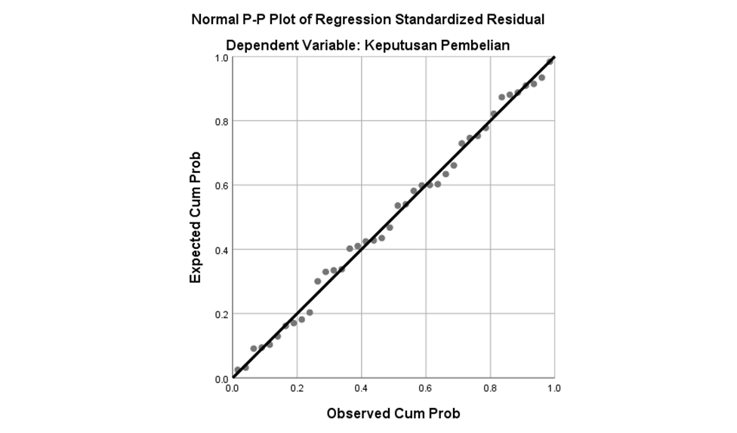

Figure 2. Normality Test Results
Source: SPSS version 25 output

From Figure 2, it can be seen that the data is spread around the diagonal line and follows the direction of the diagonal line. The fact to prove that the regression product meets the assumption of normality, because the data from the results of respondents' answers about segmenting, targeting, positioning, and purchasing decisions are spread between the diagonal lines.
- Multicollinearity Test
Based on the research results that have been analyzed using SPSS, the following values ​​were obtained:

Table 6. Multicollinearity Test
Coefficientsa
Model |  | Collinearity Statistics
 |  | Tolerance | VIF
1 | (Constant)
1 | Segmentation | .211 | 4,746
1 | Targeting | .683 | 1,464
1 | Positioning | .237 | 4.220
a. Dependent Variable: Purchase Decision
Source: SPSS version 25 output

From table 6, it can be seen that in the regression product there is no multicollinearity or perfect correlation between the independent variables. The criteria for no multicollinearity are the VIF segmenting, targeting, and positioning values ​​are less than 10 and the tolerance value is greater than 0.1.
- Heteroscedasticity Test
Based on the classical assumption test using the SPSS program, the following image was obtained:
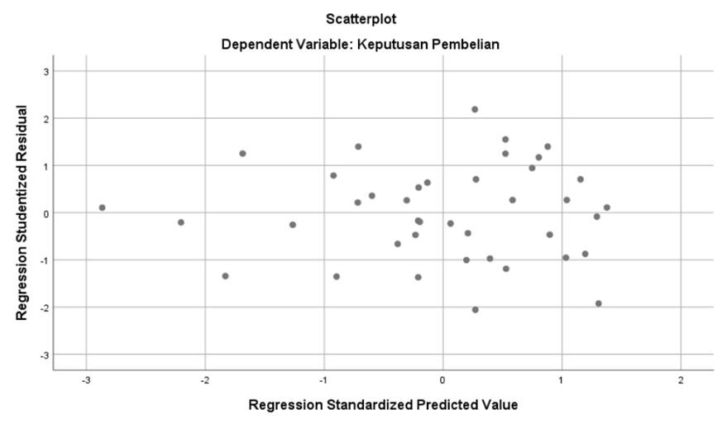

Figure 3. Heteroscedasticity Test
Source: SPSS version 25 output

Based on Figure 3, it is known that there is no clear pattern, and the points are spread above and below the number 0 on the Y axis, so there is no heteroscedasticity. This can be interpreted that the data from the results of respondents' answers about segmenting, targeting, and positioning do not have the same standard deviation or data deviation towards purchasing decisions.

Y= a + b1X1 + b2X2 + b3X3 + e

Information
Y = purchasing decision variables
X1 = variablesegmentation
X2 = targeting variable
X3 = positioning variable
b1,b2,b3 = Regression coefficient
e = error

After conducting a classical assumption test and multiple linear regression equation, the next step is to conduct a research hypothesis test which aims to determine whether the independent variable (X) has a significant effect on the dependent variable (Y).

Multiple Linear Regression Analysis
The results of the multiple linear regression analysis can be seen in the following table:
Table 7. Results of Multiple Linear Regression Analysis
Coefficientsa
Model |  | Unstandardized Coefficients |  | Standardized Coefficients
 |  | B | Std. Error | Beta
1 | (Constant) | 1,731 | 3,728
1 | Segmentation | .115 | .226 | .110
1 | Targeting | .367 | .144 | .304
1 | Positioning | .567 | .226 | .510
a. Dependent Variable: Purchase Decision
Source: SPSS version 25 output

Based on the calculation results in table 7, the regression equation is arranged as follows:
Y = 1.731 + 0.115 X1 + 0.367 X2 + 0.567 X3
It means :
    - a = 1.731 : ifsegmenting (X1), targeting (X2) and positioning (X3) are assumed to have no influence at all (=0) then the purchasing decision is 1.731.
    - b1 = 0.115 : meaning ifsegmenting (X1) increases by 1 (one) unit and targeting (X2) and positioning (X3) remain the same, then the purchasing decision will increase by 0.115 units.
    - b2 = 0.367 : meaning iftargeting (X2) increases by 1 (one) unit, segmenting (X1) and positioning (X3) remain the same, then the purchasing decision will increase by 0.367 units.
    - b3 = 0.567: this means that if positioning (X3) increases by 1 (one) unit, segmenting (X1) and targeting (X2) remain the same, then purchasing decisions will increase by 0.567 units.

Coefficient of Determination
The coefficient of determination is used to determine how much influence the independent variable has on the dependent variable. The value of the coefficient of determination is determined by the adjusted R square value as seen in table 8:

Table 8.Determination Test Results
Model Summaryb
Model | R | R Square | Adjusted R Square | Std. Error of the Estimate
1 | .805a | .649 | .619 | 3.42232
a. Predictors: (Constant), Positioning, Targeting, Segmenting
b. Dependent Variable: Purchase Decision
Source: SPSS version 25 output

Based on table 8, it is known that the adjusted R square value is 0.619. This shows that the magnitude of the influence of segmenting, targeting, and positioning on purchasing decisions is 62%, meaning that there are still other variables that influence purchasing decisions by 38%, but these variables were not examined in this study, because they have been adjusted to the number of independent variables.

Hypothesis Testing
- t-test (Partial/individual influence test)
Based on the results of the t-test that has been carried out, the following values ​​were obtained:
Table 9. t-Test Results
Coefficientsa
Model |  | t | Sig.
1 | (Constant) | .465 | .645
1 | Segmentation | 2,512 | .012
1 | Targeting | 2,540 | .016
1 | Positioning | 2,511 | .017
a. Dependent Variable: Purchase Decision
Source: SPSS version 25 output

Based on the calculations in table 9, it is known that:
  - The segmentation variable obtained a significance value of 0.012 < 0.05 and a tcount value of 2.512 while the ttable was 1.683 which means that tcount > ttable so that it means that H0 (it is suspected that segmentation does not affect purchasing decisions) is rejected and H1 (it is suspected that segmentation affects purchasing decisions) is accepted. Thus it is proven that segmentation (X₁) partially or individually has a significant influence on purchasing decisions (Y).
  - The targeting variable obtained a significance value of 0.016 < 0.05 and a tcount value of 2.540 while the ttable was 1.683 which means that tcount > ttable so that it means that H0 (it is suspected that targeting does not affect purchasing decisions) is rejected and H2 (it is suspected that targeting affects purchasing decisions) is accepted. Thus it is proven that targeting (X₂) partially or individually has a significant influence on purchasing decisions (Y).
  - The positioning variable obtained a significance value of 0.017 < 0.05 and a t-count value of 2.511 while the t-table was 1.683, which means that t-count > t-table, so that H0 (it is suspected that positioning does not affect purchasing decisions) is rejected and H3 (it is suspected that positioning affects purchasing decisions) is accepted. Thus, it is proven that positioning (X₃) partially or individually has a significant influence on purchasing decisions (Y).

- F test (simultaneous influence test)
Based on the results of the F test that has been carried out, the following values ​​were obtained:
Table 10. F Test Results
ANOVA
Model |  | Sum of Squares | df | Mean Square | F | Sig.
1 | Regression | 778,358 | 3 | 259,453 | 22.152 | .000b
1 | Residual | 421,642 | 36 | 11,712
1 | Total | 1200.000 | 39
a. Dependent Variable: Purchase Decision
b. Predictors: (Constant), Positioning, Targeting, Segmenting
Source: SPSS version 25 output

From the calculation of table 10, it is known that the sig. value is 0.000 < 0.05 and Fcount is 22.152 > Ftable of 2.606, which means that H0 (suspected segmenting, targeting, and positioning do not affect purchasing decisions) is rejected and H4 (suspected segmenting, targeting, and positioning affect purchasing decisions) is accepted. So it is proven that simultaneously segmenting (X1), targeting (X2), and positioning (X3) have a significant effect on purchasing decisions (Y).

DISCUSSION
From the test results conducted by the researcher, it was found that the three variables have a significant influence on purchasing decisions. The explanation of each variable will be explained as follows:

The Influence of Segmenting Variables Partially on Purchasing Decisions at Pondok Salero Restaurant, Kediri
The segmentation variable (X1) partially has a significant effect on purchasing decisions (Y). Because the results of the statistical test in table 9 show that the segmentation variable obtained a significance value of 0.012 <0.05 and a t-count value of 2.512 while the t-table is 1.683, which means that t-count> t-table, so that H0 is rejected and H1 is accepted. Thus, it is proven that segmentation (X1) partially or individually has a significant effect on purchasing decisions (Y). This means that by understanding market segmentation, a business can identify consumer groups that have similar needs, preferences, or characteristics. This study supports research conducted by[5]which states that segmentation has a significant influence on purchasing decisions.
In addition, this research is also in accordance with the theory put forward by[2]The concept of market segmentation is dividing the market into certain heterogeneous segments using one or more attributes, such as age level, income, geography, lifestyle to determine the number of potential customers.
Based on the results of research and expert theories, the implementation of appropriate segmentation carried out by the Pondok Salero Kediri restaurant is the key to attracting attention and winning the hearts of consumers, thus having a positive impact on business success.
The Influence of Targeting Variables Partially on Purchasing Decisions at Pondok Salero Restaurant, Kediri
The targeting variable (X2) partially has a significant effect on purchasing decisions (Y). Because the results of the statistical test in table 9 show that the targeting variable obtains a significance value of 0.016 <0.05 and a tcount value of 2.540 while the ttable is 1.683 which means that tcount> ttable so that it means that H0 is rejected and H2 is accepted. Thus it is proven that targeting (X2) partially or individually has a significant effect on purchasing decisions (Y). This means that by carrying out effective targeting, companies can significantly influence consumer purchasing decisions. This study supports research conducted by[6]which states that targeting has a significant influence on purchasing decisions.
In addition, this research is also in accordance with the theory put forward by[3]Targeting or determining the target market is a marketing activity in selecting and evaluating the market that will be used as a target or objective for offering the products produced.
Based on the results of research and theories of experts, the targeting carried out by the Pondok Salero Kediri restaurant is right, it can help business actors understand and serve the target market more effectively. By focusing on relevant customer segments, businesses can increase consumer appeal, marketing efficiency, so that it directly influences consumer purchasing decisions.
The Influence of Positioning Variables Partially on Purchasing Decisions at Pondok Salero Restaurant, Kediri
The positioning variable (X2) partially has a significant effect on purchasing decisions (Y). Because the results of the statistical test in table 9 show that the positioning variable obtained a significance value of 0.017 <0.05 and a t-count value of 2.511 while the t-table is 1.683, which means that t-count> t-table, so that H0 is rejected and H3 is accepted. Thus, it is proven that positioning (X2) partially or individually has a significant effect on purchasing decisions (Y). This means that effective positioning can influence purchasing decisions by building emotional, functional, or unique value appeals that are relevant to consumers. This study supports research conducted by[8]which states that positioning has a significant influence on purchasing decisions.
In addition, this research is also in accordance with the theory put forward by[4]stated that positioning is how to position a company's product that will be stored in the minds of consumers, companies need to understand how the brand of the product is always positioned in the minds of consumers.
Based on the results of research and theories of experts, in the application of proper positioning at the Pondok Salero Kediri restaurant, positioning becomes an important element in a marketing strategy that influences how consumers view and decide to buy a product. By creating clear differentiation, building credibility, and providing emotional and functional value, effective positioning helps consumers make purchasing decisions with more confidence.
The Influence of Segmenting, Targeting, and Positioning Variables Simultaneously on Purchasing Decisions at Pondok Salero Restaurant, Kediri
Based on table 8, it is known that the adjusted R square value is 0.619. This shows that the magnitude of the influence of segmenting, targeting, and positioning on purchasing decisions is 62%, meaning that there are still other variables that influence purchasing decisions by 38%, but these variables were not examined in this study, because they have been adjusted to the number of independent variables, and in table 10, segmenting (X1), targeting (X2) and positioning (X3) obtained a significance value of 0.000, because the probability of 0.000 <0.05 and Fcount of 22.152> Ftable of 2.606, then H0 is rejected and H4 is accepted. This means that segmenting (X1), targeting (X2) and positioning (X3) simultaneously influence purchasing decisions.
The results of this study are in accordance with the results of research conducted by[5],[6], And[8]states that segmenting, targeting, and positioning influence purchasing decisions. Segmenting, Targeting, and Positioning (STP) strategy is a key framework in marketing that helps businesses understand the market, identify the right audience, and create unique value. Effective STP implementation directly influences purchasing decisions by making products or services more relevant, attractive, and in line with consumer needs.
Based on the results of previous research and research, then by implementing a segmentation strategy, Pondok Salero Kediri restaurant can understand the market. With targeting, Pondok Salero Kediri restaurant can determine the most potential segment. And with positioning, Pondok Salero Kediri restaurant creates a unique and attractive product perception. Effective STP implementation not only increases sales opportunities but also builds long-term relationships with consumers, and creates business sustainability.

4. Conclusion
Based on the results of the research and data analysis that has been carried out, it can be concluded that:
  - There is a significant partial influence of segmentation on purchasing decisions at the Pondok Salero Kediri restaurant.
  - There is a significant influence of partial targeting on purchasing decisions at the Pondok Salero Kediri restaurant.
  - There is a significant partial influence of positioning on purchasing decisions at the Pondok Salero Kediri restaurant.
  - There is a significant influence of segmenting, targeting, and positioning simultaneously on purchasing decisions at the Pondok Salero Kediri restaurant.
For Pondok Salero Kediri restaurant, it is recommended to continue to improve segmentation, targeting, and positioning strategies. Pondok Salero Kediri restaurant can improve purchasing decisions by understanding customers, targeting potential segments, and creating a unique image. Implementing the right STP strategy, Pondok Salero Kediri restaurant can better understand market needs, target appropriate segments, and create an attractive image. Efforts such as providing relevant menus, attractive promotions, and satisfying dining experiences can improve customer purchasing decisions while creating long-term loyalty.
Because in this study it is proven that there are still other variables that influence purchasing decisions but are not discussed in this study, this can be used as material to conduct further similar research by including other variables that are not yet in this study such as price, location and facilities variables in order to obtain better results.
References
[1] IA Cyril, GA Okwandu, and KC Adiele, “Correlational Evaluation of Cost Management and Supply Chain Performance of Food and Beverages Firms in Port Harcourt,”Arch. Bus. Res., vol. 9, no. 4, 2021, doi: 10.14738/abr.94.9845.
[2] D. Saladin and YM Oesman,The Essence of Marketing and Marketing Elements. 2020.
[3] MAS Amin and P. Priansah, "Marketing Communication Strategy to Improve Tourism Potential,"Budapest Int. Res. Critics Inst. Humanite. Soc. Sci., vol. 2, no. 4, 2019, doi: 10.33258/birci.v2i4.575.
[4] P. & Kotler and G. Armstrong,Principles of Marketing Global Edition. 2018.
[5] MFF Kasim, S. Samdin, W. Hamid, H. Hartini, and E. Sukotjo, “THE INFLUENCE OFSegmenting, Targeting and Positioning (STP) on Purchasing Decisions at KM Warmindo,” J. Manaj. and Entrepreneurship, vol. 15, no. 2, 2023, doi: 10.55598/jmk.v15i2.43075.
[6] A. Manap, “Analysis of the Influence of Segmenting, Targeting and Positioning on Purchasing Decisions at Saung Berkah Cibinong Bogor Restaurant,” J. GEEJ, vol. 7, no. 2, pp. 87–94, 2020.
[7] S. Sudarso, “Analysis of Segmenting, Targeting and Positioning Implementation on Purchasing Decisions at Kedai Abg Sidoarjo,” J. Ris. Entrep., vol. 5, no. 1, 2022, doi: 10.30587/jre.v5i1.3342.
[8] R. Suhandito and M. Habib, “The Influence of Segmenting, Targeting and Positioning Strategies on Product Purchasing Decisions at Warkop Kamandanu Tulungagung,”TrendingJournal of Econ. Account. and Manaj., vol. 2, no. 2, pp. 52–68, 2024, [Online]. Available: https://doi.org/10.30640/trending.v2i2.2225
[9] Mr. Sugiyono,Quantitative, Qualitative, and R&D Research Methods. Bandung:CV: Alfabeta, 2023.

