ANALYSIS OF THE INFLUENCE OF DIGITAL MARKETING, CONTENT MARKETING, AND SPONSORSHIP ON BRAND AWARENESS (STUDY IN NATIONAL EXPORT SCHOOL)
Ayuneira Dega Pripinda, Dyah Ayu Paramitha, M.Ak
PGRI Nusantara University Kediri, KH Achmad Dahlan Street No. 76, 64112, Indonesia.
Ayuneira.99@gmail.com, dyahparamithakdr@gmail.com
*corresponding author

Article Information |  |  | Abstract
Submission date |  | Research aim : The purpose of this study is to analyze the influence of digital marketing, content marketing, and sponsorship on brand awareness in national export schools.  Design/Methode/Approach : Quantitative research methods were used for this study, utilizing observations, interviews, and questionnaires for data collection. Statistical analysis, including hypothesis testing, determination coefficients, validity tests, reliability, normality, heteroskedasticity, multicollinearity, linear regression, bwr, t-test, f test, determination coefficient, was carried out using SPSS 25.0.  Research Finding : This study reveals that digital marketing, content marketing, and sponsorship, greatly affect brand awareness for target markets or prospective students and students of the National Export School. Based on the validity test, normality, heteroscedasticity, multicollinearity, linear regression, multiple tests, t test, f test, determination coefficient, showed a positive influence.  Theoretical contribution/Originality : This study contributes to the existing literature by showing the importance of digital marketing, content marketing, and sponsorship to brand awareness. This is in line with previous research that emphasized the importance of factors such as digital marketing, content content marketing, social media, and promotions in creating brand awareness  Practitionel/Policy implication : : The findings of this study can be used by companies to develop more focused marketing strategies, utilizing digital marketing, content marketing, and sponsorship to increase brand awareness. This research also provides insight into the effectiveness of using digital platforms in increasing brand visibility, so that companies can be more optimal in utilizing digital tools.  Research limitation : This research is limited to prospective students, students, and alumni of the National Export School who receive JJE International Sponsorship.  Keywords : digital marketing, content marketing, sponsorship, and  brand awareness.
Revised date
Accepted date
1. Introduction
In today's digital era, the advancement of the internet and technology has succeeded in creating great advances in the world of marketing. One aspect that has undergone a significant transformation is marketing through digital platforms. Digital marketing, content marketing, and sponsorship have become three important parts that affect how companies market their products and services. In this context, national export schools, as educational institutions engaged in export and import skills training, are also increasingly paying attention to the use of digital media in increasing company brand awareness. Brand awareness is important in creating a relationship between consumers and brands. The higher the level of brand awareness, the greater the opportunity for a brand to be known and chosen by consumers. Therefore, national export schools need to optimize the use of digital marketing, content marketing, and sponsorship to increase their brand awareness.

Based on previous research on this topic, digital marketing, content marketing, and sponsorship have positive values that affect brand awareness. For example, research by Smith and Chaffey found that digital marketing strategies can significantly increase brand recognition, especially through the use of social media advertising and email marketing. A study that Johnson and Matthysee have conducted also shows that content marketing focused on providing useful information can increase audience engagement, leading to increased brand awareness. Meanwhile, a study by Deitz and Homburg states that sponsorship can have a positive impact on brand awareness, especially in the context of events or campaigns that involve a wide target audience.

Digital marketing is the application of Internet technology and digital platforms in carrying out marketing activities, ranging from promoting products to communicating information about brands and product offerings. Digital marketing has changed the way businesses and several other organizations interact with their customers. Customers have easy access to a wide range of products, services, and prices from various providers, as well as many options for choosing and paying for products and services. [1] Digital Branding is a marketing activity that involves online media, using the internet in the form of social media, e-mail, websites, TV, mobile/wireless, and others. To target, profile, and engage target audiences. It provides information about the behavior, value of the product, and more. So that the loyalty of customers, consumers or target consumers achieves the company's goals. [2]

Content marketing is a marketing strategy that channels, designs, and creates interesting content with the aim of attracting the target market and converting them into customers of a company. [3] Marketing content is usually designed according to the specific needs of the target market and created using storytelling techniques to make it more acceptable to the target market. So, the message must be shaped to achieve the desired results. In addition, digital media is increasingly filled with content, so only really engaging content that is well packaged can grab viewers' attention. [4] Content marketing is also advertising created online applying the cultural context of social communities including virtual worlds, news sites, social networks, and social opinion sharing sites to meet the purpose of communication. [5]
In the education sector, such as national export schools, content marketing can be used to provide in-depth information about educational services, competitive advantages, and success stories of alumni who have had successful careers in the international world. This can improve the school's image and attract the interest of prospective students who want to start their international careers.
Sponsorship is a communication tool that provides financial support for companies to smoothly carry out activities such as sports, music, and social activities, as well as get benefits such as recognition and image. That consumer. [6] Sponsors have an important role in creating a better brand image that refers to purchase intent. Sponsored subjects can influence product purchase requests more effectively than other advertising methods. This study explains the positive impact between sponsorship and purchase intent. [7] Sponsorship is a form of collateral cooperation with the aim of providing mutual benefits between the supporter and the supported party. [8]

In the national export school, sponsorship can be applied in the form of cooperation with companies or organizations relevant to the export world or internationally, such as government agencies, multinational companies, or industry associations. Sponsorship in international events or seminars can increase the school's brand awareness and create a more professional image and increase attractiveness for prospective students. In addition, the sponsorship carried out by the national export school is the JJE International program which is targeted for outstanding students in national export schools, this is a program that is always present at the end of every semester, this is one of the enticing of national export schools and a plus value compared to competitors. The purpose of this program itself is not only to be a practical learning material directly in the field, but this program can also increase brand awareness from national export schools

Brand awareness is the skill of a brand to appear in the minds of consumers when thinking about similar products Brand awareness is the first way to create a product brand. The most important thing in brand recognition is the information that is remembered first. [9] When customers spontaneously have a brand memory when a similar product is mentioned, this can be interpreted as brand awareness. Being known is desirable because it makes you feel safer and more comfortable. In other words, if your brand is already known, you have the opportunity to gain intelligence, business stability, and quality. [10] Brand awareness is the ability of customers to recognize or remember a particular brand and compare it with a certain type of product. [11]

As competition in the education industry grows faster, especially in the export-import training sector, it is important for national export schools to understand the extent of the influence of digital marketing, content marketing, and sponsorship on their brand awareness. Thus, this study aims to analyze how these three elements affect brand awareness among the audience that is the target market for national export schools.

  - Statement of Problem
As digital technology continues to develop, national export schools face challenges in maximizing visibility and brand recognition in a competitive market. Although digital marketing, content marketing, and sponsorship are known as effective strategies to increase brand awareness, there has been no research that specifically analyzes how these three elements affect the brand awareness of national export schools. Thus, this study aims to identify and analyze the influence of digital marketing, content marketing, and sponsorship on the level of brand awareness in national export schools. The findings of this study can provide insights for school management in designing more effective marketing strategies to increase their brand awareness in the global education market.

  - Research Objectives
This study has the objectives of Analyzing the influence of digital marketing on brand awareness of national export schools, Assessing the influence of content marketing on brand awareness of national export schools, Developing strategies based on the impact of sponsorship on brand awareness of national export schools, Identifying the relationship or interaction between digital marketing, content marketing, and sponsorship in increasing brand awareness of national export schools.

2. Method
The research method uses a quantitative method with a survey approach. Data will be collected through questionnaires distributed to audiences who have been exposed to digital marketing, content marketing, and sponsorship from national export schools. Data analysis will be carried out using statistical techniques to test the relationship between the variables studied, namely digital marketing, content marketing, sponsorship, and brand awareness. The data will be analyzed using SPSS (Statistical Package for the Social Sciences) software to test the relationship between the variables. This study involved 40 samples, where this sampling was based on Roscoe's opinion in the book Sugiyono, 2016, If the study will conduct an analysis with multivariate (correlation or multiple regression for example), The data is obtained from the random distribution of questionnaires.then the number of sample members is at least 10 times the number of variables studied. After obtaining the results of the questionnaire, the data will be tested for validity and realism.
- Validity Test and Reliability Test
  - Validity Test
Based on the results of the validity test based on SPSS version 25.0 released in 2024, all items meet the validity criteria as seen in the table above. This is shown by the fact that all research items have an r value of 0.312 or higher. . Therefore, all questionnaire items were declared valid and suitable for use in the study.
  - The reliability test

is a test used to measure the consistency of respondents in answering matters related to statements that are indicators of a variable compiled in a questionnaire. The reliability testing criteria in this study are the variable said to be reliable if the Cronbach Alpha value is > 60

3. Results and Discussion /Hasil dan Pembahasan
The researcher chose the location of data collection in the research at the National Export School. The data source was obtained by distributing questionnaires to prospective students, students, alumni, and alumni who received sponsorship. From the results of primary data collection on 40 respondents, the following data was obtained:
- Normality Test
a)Kolmogorov Smirnov Normality Test

Tabel 1.1

Hasil Uji Normalitas One-Sample Kolmogorov-Smirnov

One-Sample Kolmogorov-Smirnov Test
 |  | Unstandardized Residual
N |  | 40
Normal Parameters^{a,b} | Mean | .0000000
Normal Parameters^{a,b} | Std. Deviation | 1.43946445
Most Extreme Differences | Absolute | .071
Most Extreme Differences | Positive | .071
Most Extreme Differences | Negative | -.053
Test Statistic |  | .071
Asymp. Sig. (2-tailed) |  | .200^{c,d}
a. Test distribution is Normal.
b. Calculated from data.
c. Lilliefors Significance Correction.
b) From the results of the normality test with the Kolmogorov-Smirnov method, a significant result of the normality test was obtained of 0.200, and the result exceeded the significance level of 0.05, so it can be concluded that the normality test in this study is normal. . I can do it. It will be distributed. Test of Normality p – plot

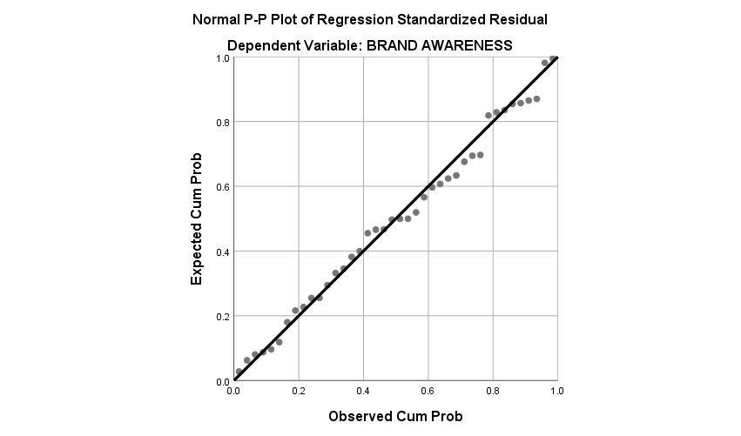
Figure 1.1

From the results of the image above, it can be seen that the results of data processing show that the data in this study is normally distributed, and the data is distributed around the diagonal and follows the diagonal direction. Therefore Ho was accepted and Ha was rejected. Because the data of this study is normally distributed, it can be concluded that the data is suitable for use in research.
1). Multicollinearity Test
The multicollinearity test aims to test whether the regression model finds a correlation between independent variables. Multicollinearity can be identified using inflation tolerance and variance factors (VIFs). The commonly used limit to indicate the presence of multicollinearity is a tolerance of <0>10.

Tabel 1.2
Multicollinearity Test Results

Unstandardized Coefficients |  |  |  | Standardize  d Coefficients | T | Sig. | Collinearity Statistics
Model |  | B | Std. Error | Beta | T | Sig. | Toleranc e | VIF
1 | (Constant) | 1.303 | 3.964 |  | .329 | .744
1 | DIGITAL MARKETING | .259 | .086 | .366 | 3.005 | .005 | .493 | 2.029
1 | CONTENT MARKETING | .360 | .086 | .496 | 4.164 | .000 | .516 | 1.937
1 | SPONSORSHIP | .224 | .099 | .201 | 2.265 | .030 | .934 | 1.070
a. Dependent Variable: BRAND AWARENESS
Source: SPSS 25.0 Data Processing Results, 2024
The table above shows that the Variables X1,X2 and X3 have a VIF value below 10, and a tolerance value of more than 0.1, the model can be said to have no multicollinearity.
2) Heteroscedasticity Test
The heteroscedasticity test aims to test whether in the regression model there is a variance inequality from the residual of one observation to another. A regression model that can be said.
a)Heteroscedasticity Test of Scatter Plot Method
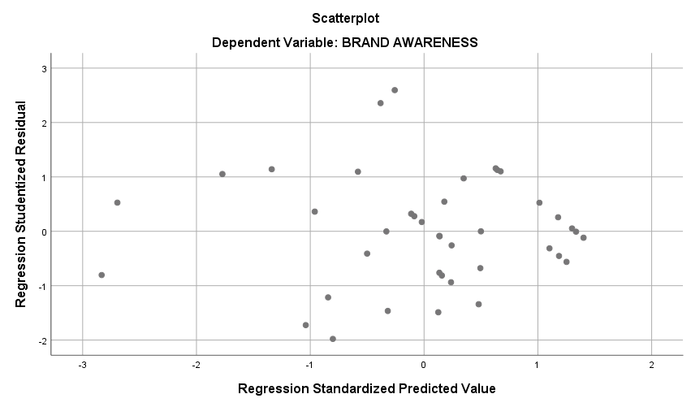

FIGURE 1.2
From the results of the image above, it can be seen that the results of data processing obtained that the data in this study did not occur heteroscedasticity, where the data spread around the diagonal line. It can be concluded that the data of this study does not occur heteroscedalysis so that it is suitable for use in research.

B. Multiple Regression Test
The multiple linear regression test is used to measure the strength of the relationship between two or more variables and indicate the direction of the relationship between the bound and free variables. In this study, a multiple linear regression test was used to measure the relationship between independent variables, namely digital marketing, content marketing, and service quality, as well as the bound variable, namely brand awareness.

Tabel 1.3
Multicollinearity Test Results
Coefficientsª
Unstandardized Coefficients |  |  |  | Standardized Coefficients |  | Sig.
Model |  | B | Std. Error | Beta |  | Sig.
1 | (Constant) | 1.303 | 3.964 |  | .329 | .744
1 | DIGITAL MARKETING | .259 | .086 | .366 |  | .005
1 | CONTENT MARKETING | .360 | .086 | .496 |  | .000
1 | SPONSORSHIP | .224 | .099 | .201 |  | .030
a. Dependent Variable: BRAND AWARENESS Source: SPSS 25.0 Data Processing Results, 2024
Y = 1.303 + 0.259X1 + 0.360 X2 + 0.224X3 + e
Based on the regression equation, it can be seen that the value of the coefficient of the independent variable is 1.303, meaning that if the independent variable increases by one unit, then the dependent variable (Brand Awareness) will increase by 1.303
The Digital Marketing variable of 0.259 shows that if the value of Digital Marketing is increased from one unit, then Brand Awareness increases by 0.259 The Content Marketing variable of 0.360 shows that if the Content Marketing value is increased from one unit, then Brand Awareness increases by 0.360
The Sponsorship variable of 0.224 shows that if the value of Content Marketing is increased from one unit, then Brand Awareness increases by 0.224

Tabel 1.4
DIGITAL  MARKETI NG |  |  |  | CONTENT  MARKETIN G | SPONSORS HIP | BRAND AWARENESS
DIGITAL MARKETING |  | Pearson Correlation | 1 | .694** | .250 | .761**
 |  | Sig. (2-tailed) |  | .000 | .119 | .000
N |  |  | 40 | 40 | 40 | 40
CONTENT MARKETING |  | Pearson Correlation | .694** | 1 | .134 | .777**
 |  | Sig. (2-tailed) | .000 |  | .412 | .000
 |  | N | 40 | 40 | 40 | 40
SPONSORSHIP |  | Pearson Correlation | .250 | .134 | 1 | .359*
 |  | Sig. (2-tailed) | .119 | .412 |  | .023
 |  | N | 40 | 40 | 40 | 40
BRAND AWARENESS |  | Pearson Correlation | .761** | .777** | .359* | 1
BRAND AWARENESS |  | Sig. (2-tailed) | .000 | .000 | .023
BRAND AWARENESS | N |  | 40 | 40 | 40 | 40
**. Correlation is significant at the 0.01 level (2-tailed).
*. Correlation is significant at the 0.05 level (2-tailed).
Based on the calculation, the correlation coefficient of variable X1 to Variable Y was obtained of 0.761. Based on the results of the calculation, it means that the influence of x1 on y and the influence of x1 on y is Strong.
Then the correlation coefficient of the X2 variable against the Y variable is 0.777. Based on the results of the calculation, it means that the influence of x2 on y and the influence of x2 on y is Strong.
Then the correlation coefficient of the X3 variable to the Y variable is 0.357. Based on the results of the calculation, it means that the influence of x3 on y and the influence of x2 on y is low.
C. Hypothesis Test
- Test T
The t-test in this study aims to show how much influence each independent variable has on the dependent variable. The test value carried out is tcal, the significance value is <0> ttable, and the significance value is <0> 0.05, then the hypothesis is rejected.

Tabel 1.5
Coefficientsª
Unstandardized Coefficients |  |  |  | Standardized Coefficients |  | Sig.
Model |  | B | Std. Error | Beta |  | Sig.
1 | (Constant) | 1.303 | 3.964 |  |  | .744
1 | DIGITAL MARKETING | .259 | .086 | .366 | 3.005 | .005
1 | CONTENT MARKETING | .360 | .086 | .496 | 4.164 | .000
1 | SPONSORSHIP | .224 | .099 | .201 | 2.265 | .030
a. Dependent Variable: BRAND AWARENESS

- Test F

Tabel 1.6
ANOVAª
Model |  | Sum of Squares | Df | Mean Square | F | Sig.
1 | Regression | 225.590 | 3 | 75.197 | 33.499 | .000^{b}
1 | Residual | 80.810 | 36 | 2.245
1 | Total | 306.400 | 39
- Dependent Variable: BRAND AWARENESS
- Predictors: (Constant), SPONSORSHIP, CONTENT MARKETING, DIGITAL MARKETING

The results of the table above, show that the significance value is 0.000< 0.05 and the value of f calculation (33.499) > f table (3.25), then Hypothesis 4 is accepted and it can be concluded that there is a positive influence together between Digital Marketing, Content Marketing and Sponsorship on Brand Awareness.
- Determination Coefficient Test (R2)

Tabel 1.7
Model Summary
Model | R | R Square | Adjusted R Square | Std. Error of the Estimate
1 | .858ª | .736 | .714 | 1.498
  - Predictors: (Constant), SPONSORSHIP, CONTENT MARKETING, DIGITAL MARKETING
Source: SPSS 25.0 Data Processing Results, 2024

Based on the output of SPSS 25.0 in 2024, it is known that the value of the determination coefficient (R Square) is 0.736. This number means that the variables Digital Marketing, Content Marketing, and Sponsorship have an influence on Brand Awareness by 73.6% while the other 26.4% are influenced by other variables that were not studied in this study.
The purpose of this study is to determine the comparative significance of three variables— transformational Digital Marketing (X1), Content Marketing (X2), and Sponsorship (X3)— into Brand awareness (Y). value each variable. The questionnaire uses non-probability sampling, adopting a quantitative methodology. Concretely, this study investigates the following three hypotheses: The influence of Digital Marketing on the brand awareness of students, prospective students, and alumni of national export schools The t-value shows that the significant value is 0.005 with a t-value calculated > 2.026. With a significance of 0.005 < 0.05, Ho was rejected and H1 was accepted and it can be concluded that Digital Marketing (X1) has a significant positive effect on Brand Awareness (Y) The influence of Content
Marketing (X2) on Brand Awareness (Y) shows that a significant value of 0.000 with a t-value of 4.164 > 2.026. With a significance of 0.000 < 0.05, Ho was rejected and H2 was accepted and it can be concluded that Content Marketing (X2) has a significant positive effect on Brand Awareness (Y) Sponsorship Influence (X3)
to Brand Awareness (Y) shows that the significant value is 0.007 with a t-value of 2.265 >
2.026. With a significance of 0.030 < 0.05, Ho was rejected and H3 was accepted and it can be concluded that Sponsorship (X3) has a significant positive effect on Brand Awareness (Y)
The SPSS output results show the significance statistics of the sign or probability of 71,492 critical 3.11 according to the SPSS output. The findings of the considered test are acceptable if they mark probabilities simultaneously. The freestyle of Digital Marketing (X1), the bound variables of Content Marketing (X2), and Sponsorship (X3) together have an effect on Brand Awareness (Y) if analyzed simultaneously. Studies[12] validate, show that digital marketing, content marketing, and sponsorship have a positive impact on brands
This study found that digital marketing, content marketing, and sponsorship have a significant effect on brand awareness, with digital marketing being the most dominant factor. These results are in line with previous research by Rahmawati (2021) which stated that the consistent use of digital media is able to significantly increase brand visibility. In addition, these findings reinforce a study from Nugroho & Lestari (2020) that shows that engaging and relevant content directly improves consumers' recall of brands. Meanwhile, although the influence of sponsorship is lower, these results are still consistent with Wibowo's (2019) study which confirms that sponsorship has a positive impact on brand recall in the context of certain events. Thus, an integrated marketing strategy between digital marketing, content marketing, and sponsorship is recommended to maximize overall brand awareness.

The result, of this study show that each variable, digital marketing (X1), content marketing (X2),
Sponsorship (X3) has a positive effect on brand awareness ( Y).Theoretically, this research
enriches the understanding of digital marketing, content marketing, sponsorship to brand awareness.

The influence of the combination as a whole, digital branding, content marketing, and sponsorship simultaneously proved to have a strong influence on increasing brand awareness of the National Export School. These three variables support each other in building better brand awareness in an increasingly competitive market.

4. Conclusion
The result, of this study show that each variable, digital marketing (X1), content marketing (X2), Sponsorship (X3) has a positive effect on brand awareness ( Y).Theoretically, this research enriches the understanding of digital marketing, content marketing, sponsorship to brand awareness.The influence of the combination as a whole, digital branding, content marketing, and sponsorship simultaneously proved to have a strong influence on increasing brand awareness of the National Export School. These three variables support each other in building better brand awareness in an increasingly competitive market.
References
- Zuhroh NF, Pradhani FA. Peran Sistem Informasi Dalam Implementasi Digital Marketing: a Systematic Literature Review. J Ilm Manaj Dan Bisnis 2024;3:174–87. https://doi.org/10.24034/jimbis.v3i2.6690.
- Syam DL, Mayangsari ID. Pengaruh Digital Marketing Terhadap Brand Awareness : Studi Kasus Kandang Ayam Resto. Reslaj Relig Educ Soc Laa Roiba J 2024;6:197–211. https://doi.org/10.47476/reslaj.v6i1.3268.
- Limandono JADD. Pengaruh Content Marketing Dan Event Marketing Terhadap Customer Engagement Dengan Sosial Media Marketing Sebagai Variabel Moderasi Di Pakuwon City. J Strateg Pemasar 2018;5:11.
- Pandrianto N, Sukendro GG. Analisis Strategi Pesan Content Marketing Untuk Mempertahankan Brand Engagement. J Komun 2018;10:167. https://doi.org/10.24912/jk.v10i2.2619.
- Kamanda SV. Pengaruh Content Marketing Terhadap Minat Beli Produk Cimory Pada Sinar Mart. J Al-Amal 2023;2:1–7.
- Salma AN. PENGARUH SPONSORSHIP DALAM MENINGKATKAN BRAND
AWARENESS (Studi pada Sponsorship Garuda Indonesia Terhadap Liverpool FC sebagai Global Official Airline Partner). Inject (Interdisciplinary J Commun 2018;2:1. https://doi.org/10.18326/inject.v2i1.1-26.
- Vitadiani R, Mudiantono DH, Manajemen J. ANALISIS PENGARUH SPONSORSHIP, PENGALAMAN KONSUMEN, DAN PROMOSI PENJUALAN TERHADAP MINAT BELI KONSUMEN DENGAN KESADARAN MEREK
SEBAGAI VARIABEL INTERVENING (Studi pada konsumen ekspatriat penerbangan domestik Garuda Indonesia). Diponegoro J Manag 2017;5:1–10.
- Wikramayana IGPS, Pramudana KAS. PERAN BRAND IMAGE DALAM MEMEDIASI PENGARUH SPONSORSHIP TERHADAP NIAT BELI MOTOR
YAMAHA DI Fakultas Ekonomi dan Bisnis Udayana , Bali – Indonesia kerjasama berupa sponsorship dalam penyelenggaraan pada berbagai event baik ( ISL ) menjalin kerjasama sponsor 2014.
- Rumaidlany D, Mariam S, Ramli AH. Pengaruh Brand Image Dan Brand Awareness Terhadap Keputusan Pembelian Pada Mc Donald’S Di Palmerah Jakarta Barat. J Lentera
Bisnis 2022;11:102. https://doi.org/10.34127/jrlab.v11i2.567.
- Andata CP, Iflah I. Pengaruh Media Sosial Dalam Meningkatkan Brand Awareness “Somethinc” Pada Pengguna Instagram Di JABODETABEK. J Komun 2022;13:84–92.
https://doi.org/10.31294/jkom.v13i2.13261
- Prayogo A, Fauzi A, Sapto Bagaskoro D, Aditya Alamsyah F, Tonda F, Kamil Hafidzi M, et al. Pengaruh Brand Image, Viral Marketing dan Brand Awareness Terhadap Minat Beli Konsumen. J Ilmu Multidisplin 2023;1:754–63. https://doi.org/10.38035/jim.v1i4.116.

