THE INFLUENCE OF WORK-LIFE BALANCE, WORK STRESS, AND WORK ENVIRONMENT ON EMPLOYEE SATISFACTION AT THE IMA SHOP SOUVENIR CENTER
Tuti Widiya Ningsih ^{1*}, Dyah Ayu Parmitha ²
tutiwidiyan@gmail.com*, dyah.paramithakdr@gmail.com
University of Nusantara PGRI Kediri, Jl. KH. Ahmad Dahlan No.76, Mojoroto, Kediri City, East Java, 64112, Indonesia
*corresponding author

Article Information |  |  | Abstract (dalam bahasa Inggris)
Submission date |  | Research aim : At Toko Ima Souvenir Center, this study attempts to ascertain the partial and simultaneous effects of work-life balance, work stress, and work environment on employee job satisfaction.  Design/Methode/Approach : This study uses a quantitative method with an associative approach, the population is all permanent employees at the Ima Shop Souvenir Center, samples is 30 respondents. Using SPSS version 16 software, the data analysis method employs the traditional assumption test, multiple linear regression test, determination coefficient test, and hypothesis test.  Research Finding : The findingsof this research are that there is a favorable and noteworthyinfluence of the work-life balance variable on job satisfaction, and there is no positive influence of the work stress variable on job satisfaction, and job satisfaction not positive impacted by the work environment variable. Additionally, job satisfaction is significant impacted by the variables of work-life balance, work stress, and work environment.  Theoretical contribution/Originality : This study adds to the corpus of knowledge already in human resources about work-life balance, stress at work, and the impact of the workplace regarding employment satisfaction. As well as helping MSMEs to understand the importance of creating a comfortable work environment, managing employee set-up, and supporting work-life balance to increase employee job satisfaction.  Practitionel/Policy implication : Providing policy recommendations to improve the balance between employees' work and personal lives, minimizing work stress and helping business owners to understand the importance of human resources in the success of a store.  Research limitation : This study only focuses on employees who work at the Toko Ima Souvenir Center.  Keywords : Work-Life Balance, Work Balance, and Work Environment.
Revised date
Accepted date
1. Introduction
Ministry of Cooperatives and SMEs reported that 64.2 million MSMEs operated at Indonesia, accounting for 61.07% of the nation's GDP, or 8,573.89 trillion rupiah. MSMEs are also capable of absorbing up to 60.4% of investment and 97% of the labor. However, the huge number of MSMEs is inseparable from its challenges according to [1]. The challenge in running an MSME business is in managing and managing it. One of them is human resource management that needs to be considered. According to [2]Human resource management is a field that studies how workforce relationships and roles are organized so that they can effectively and efficiently help achieve company goals. So that there are no problems that hinder their business in the future, MSME actors must learn and pay attention to this. Because usually, the progress of the business will be better with the planning and management of HR management. So a company must also know the conditions felt by its employees in order to form a balance of job satisfaction for employees.
According to [3]Paying attention to employee satisfaction is essential because it determines the perception that employees receive towards their work and their company. If the assessment is made according to people's wishes, job satisfaction will appear. Job satisfaction is a factor that motivates employees to do their jobs well. Reduced job satisfaction will affect the workplace results. Lowering contentment at work can occur due to inappropriate salary.
According to research [4], that a favorable connection between employee work-life balance andability. When the work-life balance felt by employees is better, there will be more work spirit they have. On the other hand, when the employees' perception of work-life balanceis lower, then they have less work morale. Indeed, according to [5], his opinion differed from others, he defined work-life balance in various aspects. Defining work-life balance as work stress consists of four important elements: time, behavior, time tension, and personal conflict with work. According to [6], the equilibrium between work-life and personal life is how a person can balance the demands of his job with his personal and family needs to be satisfied in his or her job. In addition tohow well work and personal life are balanced that employees have, work stress is also a factor that can affect job satisfaction.
According to [3]Work stress is one of the big problems faced by every worker in his workplace. Stress can come from pressure or tension that comes from a misalignment between a person and his or her workplace. The stress experienced by employees as a result of their unconducive work environment will affect job satisfaction, so management must improve the work environment of employees to be more effective. Studies have shown that the more stress employees feel at work, the lower their job satisfaction or vice versa. Too big an impact can threaten a person's ability to face the environment to interfere with the implementation of tasks and work which can affect their job satisfaction.
The work environment is defined as the state or circumstances that exist in the workplace, which can include workspaces, layouts, facilities, and working relationships with colleagues [6]. Employee satisfaction in achieving company goals can be achieved through a good work environment. Employees can be happier if their work environment is comfortable. According to [8], work environment factors are non-human factors, both physical and non-physical,wherein employee performance is impacted by the work environment and there is a positive correlation between the two. Therefore, organizations must pay attention to the work environment factor in their workers in order for them to perform at their best, feel comfortable, safe, and highly motivated to continue working to achieve the goals of a company.
Therefore, owners must observe the working conditions in the center of pleasant Ima souvenirs so that employees are satisfied with their work. If employees feel happy working at their workplace and are supported by a conducive, comfortable, and fun work environment, they will be more enthusiastic, diligent, diligent, initiative, and creative.
Job satisfaction depends on how satisfied or dissatisfied an employee is with his or her job, which includes all aspects[9]. Job satisfaction can also bedescribed as an assessment that characterizes an individual's feelings of happiness or unhappiness, contentment or discontentment at work. However, research on Work-Life Balance, work stress,as well as the workplace at the Ima souvenir shop center has not been done.
From the explanation of employee job satisfaction above, research can be carried out at the Ima Shop. Souvenir shops engaged in food trade where as employees have a fairly high intensity of busyness, many interactions with customers, duties and responsibilities give a better influence to the souvenir center store. So in this case, to find out more, the author took the title "THE INFLUENCE OF WORK LIFE BALANCE, WORK STRESS, AND WORK ENVIRONMENT ON JOB SATISFACTION AT THE TOKO IMA SOUVENIR CENTER"
  - Statement of Problem
This problem arises because of a certain impact that affects employee job satisfaction at the Toko Ima Souvenir Center. There are a number of external and internal elements that influence Ima Souvenir Center employees' job happiness, including the imbalance between work and personal life or what is called work-life balance, stress at work, and the work environment. This proves that there is an indication evidence that Toko Ima's staff job satisfaction is below ideal.

  - Research Objectives
At the Toko Ima Souvenir Center, this study attempts to ascertain the partial and simultaneous effects of work-life balance, work stress, and work environment on workers' job satisfaction.

2. Method
In order to determine and examine the impact of the link between independent and bound variables, this study employs a quantitative method with an associative approach. The impact of work-life balance, stress, and the workplace on job satisfaction at the Toko Ima Souvenir Center are the four factors under investigation. A Likert scale-equipped questionnaire serves as the research tool. All 30 permanent employees or a saturated sample of the Ima Shop Souvenir Center make up the participants and samples in this research. A questionnaire was utilized obtained the study's data, conventional assumption tests, tests for multiple linear regression analysis, tests for determination coefficients, and hypothesis tests were used to examine the data.

3. Results and Discussion
3.1 Validity and Reliability Test
The validity test's objective is to assess a questionnaire's dependability. " “An instrument or questionnaire is considered valid if the questions asked can reveal what the questionnaire should measure.” [10]. Validity test using the app Statistics IBM SPSS 16 to find out the indicators (questions) contained in the questionnaire.
An instrumentto evaluating a questionnaire that serves as sign of a variable or construct is a reliability test. This study was conducted to apply a test to identify the consistency and stability of respondents by providing an answer related to the statement presented in the form of a questionnaire. If a respondent's responses to a questionnaire remain constant or stable throughout time, it is considered dependable( Ghozali, 2018).
Suppose the computed r-value is higher compared the table r with a 5% sign, the validity test for the statement item is regarded as valid. If the Cronbach's alpha result is higher than 0.60, the reliability test is considered reliable. Based on the analysis's findings, the reliability test reveals that Cronbach's alpha is larger than 0.60, validity test demonstrates that the computed r-value surpasses the r-table value (valid).
3.2 Classic Assumption Test
Normality Test
Data normalcy is tested using the normality test. Regarding the normality test, if it is done with a graph, it may be deceptive if you are not attentive, because it may appear normal on the surface but may be the reverse statistically.
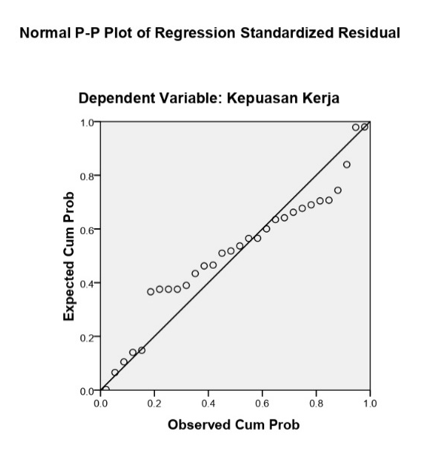

Figure 1. Normality Test

The residual assumptions that have a normal distribution can be seen in figure 1. Normal probability plot. Assuming the points on the normal probability plot spread around the slash line and paying attention to the line from end to end, therefore can be said that the residue is regularly delivered.
Multicollinearity Test

The goal of the Multicollinearity Test is to assess if the variables in a regression model are highly correlated with each other are correlated. Tolerance value and (VIF) can examined in the multicollinearity test. The assumption of the value of tolerance and(VIF) is "if the VIF value is > 10 and tolerance< 0.10,then there is multicollinearity. While the VIF value < 10 and tolerance> 0.10 means that is no multicollinearity". ( Ghozali , 2018) .
Table 1.
Multicollinearity and Multiple Linear Regression Tests

Type | Collinearity Statistic
Type | Tolerance | BRIGHT
(Constant)  Work Life Balance  Work Stress  Work Environment | ,570  ,438  ,298 | 1,755  2,281  3,359

Since the two variables' VIF values are less than 10, as can be seen from the above table, independent variables don’t exhibit any association with the presumption of multicoloniality has been met.

Heteroskedacity Test

The heteroscedasticity test is conducted to assess whether the regression model exhibits unequal variability of errors variations in residual dispersion across different observations.
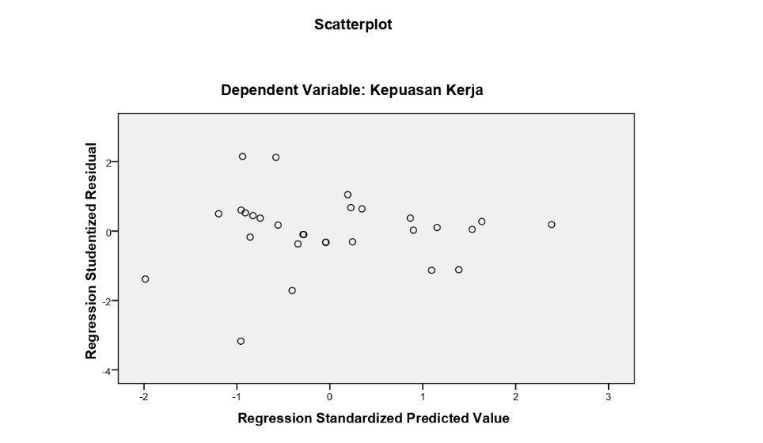

Figure 2. Heteroscedasticity test
Figure 2 displays that the randomly spread points are both above and below zero and do not exhibit any patterns, which indicates that the assumption of heteroscedasticity is met. Using the parametric coefficient, it can be inferred that if the level of significance probability value is more than 0.05, "that heteroscedasticity does not occur, on the other hand, if the significance profitability value is below 0.05, then it can be said that heteroscedasticity occurs."
Multiple Linear Regression Test

Table 2.
The double linear regression equation test's findings
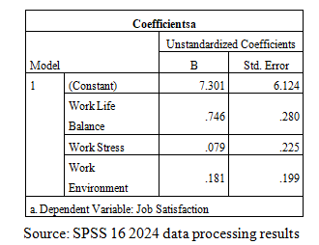

Here are the calculation results based on the preceding table:
Y= a+ b1X1+ b2X2+ b3X3
= 7.301+0. 746 X1+0. 079 X2+0, 181 X3
a= 7,301 units, if the variables Work-life Balance (X1), Work Stress (X2), Work Environment (X3) don't have any impact at all (=0), then the Job Satisfaction value is 7,301. Thus, it can be said that a number of elements, such as work-life balance, work balance, and work environment, possess an impact regarding employment satisfaction. Assuming a stable variable, the Job Satisfaction value will rise for every unit increase in the Work-life Balance variable, the value rises by 0.746 units. Moreover, job satisfaction is expected to increase by 0.079 units for each unit rise in the labor satisfaction variable and by 0.181 units for every additional unit in the Work Environment variable.
Determination Coefficient Test (R²)
The degree to which the model can account for the variance of dependent variables is determined by the determinant coefficient (R2) test; "It’s value determinant coefficient is between zero and one" [10]. The degree to where the independent variable influences the bound variable is also determined using this method. The determination coefficient is found using the value of the R rectangle.

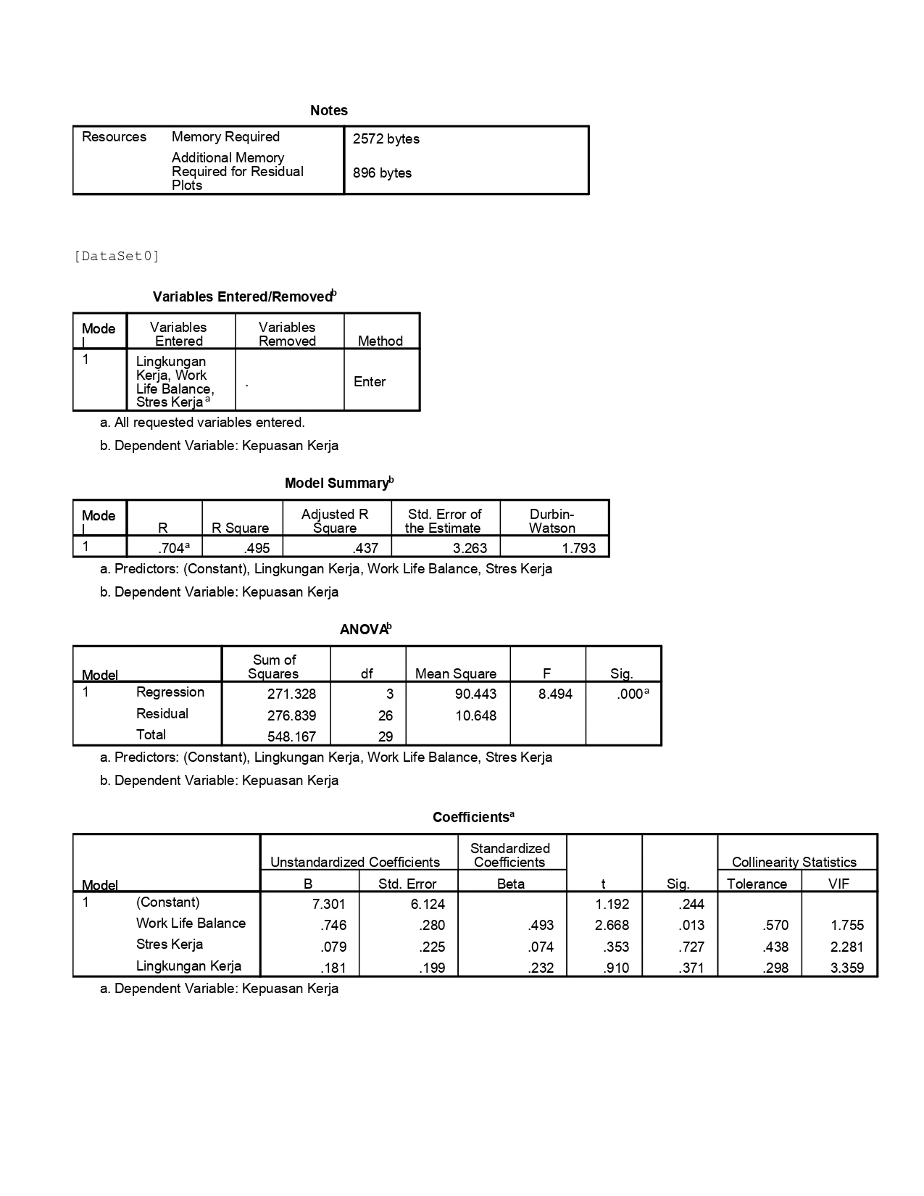
Table 4. Coefficient of Determination Test

Work-life balance, work stress, and workplace together exert an influence of 70.4% of job satisfaction, while other factors influence the remaining 29.6%, according to the outcomes of the data processing of the determination coefficient data above, which shows that the correlation coefficient value is 0.704.

Uji Hipotesis
A statistical assumption test is therefore required to determine the hypothesis in the research order to determine the degree of significance regarding the impact of independent and dependent variables.

T Test (Partial)
In this study, the objective is to determine whether there is a strong connection between variables X1, X2, and X3 and Y.

Table 2. T Test Results

The Effect of Work-Life Balance on Job Satisfaction
It clear from the preceding table that the t-value for the work-life balance variable is 2.668 > the table = 2.055 with a significance value of = 0.013 > 0.05 which means that work-life balance has a significant influence on job satisfaction which means that the hypothesis is Validated.

The Effect of Work Stress on Job Satisfaction
It is clear from the preceding table that the t-value for the variable of work stress, which is 0.353 < t, table=2.055 with significance value of = 0.727 > 0.05 is work stress does not significantly impacton job satisfaction this indicates that the theory is disproved or ineffective.

The Influence of the Work Environment on Job Satisfaction
Referring to the table, the t-value for the work environment variable is 0.910, which is lower than the t-table value of 2.055, with a significant level of 0.371, exceeding 0.05. This suggests the workplace doesn’t have a significant relationship with job satisfaction, resulting in the hypothesis being rejected or refuted.

Test F (Simultaneously)
The research of the F test, the purpose is to determine the Y variable's relevance. It can be seen in The F test computation results are displayed in the table below.
Table 3. Test Result F

That above data processing findings indicate that the statistically meaningful probabilityis 0.000 less than 0.05 and that the value of F calculation = 8.494 is greater than the F table = 2.98. Consequently, the hypothesis is accepted, and the outcome shows that job happiness is greatly impacted by work-life balance, work stress, and workplace taken together.

Discussion

The Effect of Work-Life Balance on Job Satisfaction
The study at Ima Shop Souvenir Center examining theassociation between work-life balance and job satisfaction found that work-life balance significantly affects job satisfaction. This is indicated by a calculated t-value of 2.668, which exceeds the t-table value of 2.055, with a significant level of 0.013, which is below 0.05. Suggest on H1 is accepted, and H0 is rejected, demonstrating that work-life balance plays a crucial role.
This result is evidenced by research [3]work life balance and the workplace has amajor impact on contentment at work, this relationship is explained cognitif evaluation theory The action of the work result is supported by motivation that comes from the outside, meaning that the condition of the Work Life Balance which is good is the motivation of employees, so it makes the sense of satisfaction even higher in employees. According to Maslow's theory, work-life balance It falls under the category of security needs, where people need a sense of compassion, belonging, acceptance, friendship, security, and protection from physical and spiritual threats.

The Effect of Work Stress on Job Satisfaction
Employees can experience work stress, which is a condition caused by tension and behavioral changes, such as fatigue and decreased motivation, reducing job satisfaction[11].
With a calculated t value of 0.353 < table t = 2.055 and a significant value of 0.727 < 0.05, the study's findings on theconnection between work stress and job satisfaction at Ima Souvenir Shop demonstrated that work stress had no discernible impact on job satisfaction. As a result, H2 was rejected and H0 was accepted. Therefore, it can be said that job satisfaction is not impacted in any way by work stress.
The study's findings demonstrate that employee job satisfaction is unaffected by the work environment or stress, and there are other factors that are more influential but not discussed in this study. The results showed that even though employees experienced significant stress, especially when they were working so tired that it caused stiffness in their back muscles, they still believed that when they were able to complete their tasks, they would feel satisfied[11].

The Influence of the Work Environment on Job Satisfaction
In research explores the connection between the workplace environment and employee job satisfaction at Ima Shop Souvenir Center found that the work environment variable does not significantly influence job satisfaction. As a result, H3 is rejected or deemed to have no effect. This conclusion is based on a calculated t-value of 0.910, which is lower than the t-table value of 2.055, with a significant level of 0.371, exceeding the 0.05 threshold.
According to [6] Suggest on work environment don’t have a significantly impact one’s level on job satisfaction. The return on investment differ from those of a study by Aliya & Saragih (2020) which found that job satisfaction is significantly impacted by the workplace.
The Effect of Work-Life Balance, Work Stress and Work Environment on Job Satisfaction
It is evident from the results of this F test, which were derived from the data processing above, that the F value is calculated = 8.494 > from F table = 2.98 with a significant probability value of 0.000 < 0.05. This suggests that the study's findings on the effects of work-life balance, work stress, and workplace on job satisfaction at the Ima souvenir shop center clearly demonstrate a simultaneous influence. This indicates that the decision is a valid hypothesis because work-life balance, work stress, and the workplace all significantly affect job satisfaction.
One of the most crucial elements in achieving the best possible job outcomes is employee satisfaction. When an employee is happy with their work, they will undoubtedly do their best to finish it. Employee productivity will therefore be at its peak.[12].

4. Conclusion

Considering the results of the aforementioned study, it can be said that studies on connection between work-life balance, stress, and the workplace have a substantial impact on job satisfaction. In particular, work-life balance has a considerable impact on job satisfaction. Work-related stress is not significant and has no impact on job satisfaction. This demonstrates that improving job satisfaction is not influenced by work-related stress. Job happiness is not much impacted by the workplace.
This demonstrates that improving job satisfaction is not dependent on the work environment or stress levels. In the context of work-life balance, job satisfaction at Ima Souvenir Center is significantly impacted by both the work environment and work stress. As a result, it is reasonable to assume that researchers will examine more factors that impact work-life balance, stress, and the workplace on job satisfaction in this study, along with various items that could significantly impact employees' job satisfaction.

References
[1] Haryo Limanseto. MSMEs Become an Important Pillar in the Indonesian Economy 2021:1–1.
[2] SIAGIAN S. Bahan_1_Manajemen_Sumber_Daya_Manusia_pa (1). n.d.
[3] Pitoyo DJ, Handayani WPP. The Effect of Work-Life Balance and Work Environment on Employee Job Satisfaction. J Stud Management and Business 2022; 9:152–9. https://doi.org/10.21107/jsmb.v9i2.17794.
[4] Mujahidin N, Kasran M, Sampetan S, Palopo UM. The Influence Of Work-Life Balance, Work Stress And Work Environment On Employee Performance In The Regional Financial And Asset Management Agency In Palopo City Pengaruh Work-Life Balance, Stres Kerja Dan Lingkungan Kerja Terhadap Kinerja Karyawan Pada B. Manag Stud Entrep J 2023; 4:2213–2206.
[5] Cahyadi L, Prastyani D. Work-Life Balance, Work Stress and Role Conflict on Job Satisfaction in Working Women. J Ekon J Econ 2020;11. https://doi.org/10.47007/jeko.v11i2.3576.
[6] Paryanti YI, Aprianti K. The Effect of Work-Life Balance, Work Stress and Work Environment on Employee Job Satisfaction at Bima Regional General Hospital. Bima 2022; 1:21–8.
[7] Juwita R, Marsidin S. The Influence of the Work Environment on Teacher Job Satisfaction at Management-Based State Vocational Schools 2023; 3:130–8. https://doi.org/10.58737/jpled.v3i2.131.
[8] Junaidi J. The Influence of Work Environment and Competence on Job Satisfaction and Employee Performance. J Law, Hum and Politics 2021; 1:411–26. https://doi.org/10.38035/jihhp.v1i4.720.
[9] Nurpratama M, Yudianto A. The Influence of Leadership Style and Work Facilities on Job Satisfaction in Indramayu Regency KPU Employees. J Investment 2022; 8:36–46. https://doi.org/10.31943/investasi.v8i1.184.
[10] Ghozali I. Application of multivariate analysis with IBM SPSS 25 Program. Agency 2018; 1:1–99.
[11] Firdaus RY, Wiharno H, Fitriani LK. The Effect of Workload, Work Stress, and Work-Life Balance on Job Satisfaction and Its Impact on Organizational Citizenship Behavior. J Syntax Admiration 2024; 5:1334–52. https://doi.org/10.46799/jsa.v5i4.1117.
[12] Ayunasrah T, Ratnawati R, Diana R, Ansari A. The Influence of the Work Environment on Employee Performance with Job Satisfaction as a Mediation Variable at the Bener Meriah Regency Environmental Office. J Science Science 2022; 4:1–10. https://doi.org/10.55542/juiim.v4i1.147.

